Modeling Zero Energy Elementary Schools with OpenStudio®

OpenStudio® is a whole building energy modeling software platform used to model complex interactions between the building envelope, plug loads, daylighting, lighting, and heating and cooling equipment. It has an intuitive graphical user interface that helps the user navigate through different inputs for the energy model. A unique feature of OpenStudio® is that it provides the capability to quickly implement different energy efficiency and energy conservation strategies using a set of programmatic instructions called ‘measures. The purpose of using OpenStudio® for the Race to Zero is to evaluate the impact of these energy efficiency and energy conservation strategies on the energy use intensity (EUI) of the building and ensure that it is along the path to zero energy. The OpenStudio® software is available to download for free. ­

Table of Contents

Installing OpenStudio®. 2

# Installing OpenStudio®.

1. Go to <https://www.openstudio.net/user/login> and click “Login with EnergyPlus”. Create an account if you don’t already have one.  
   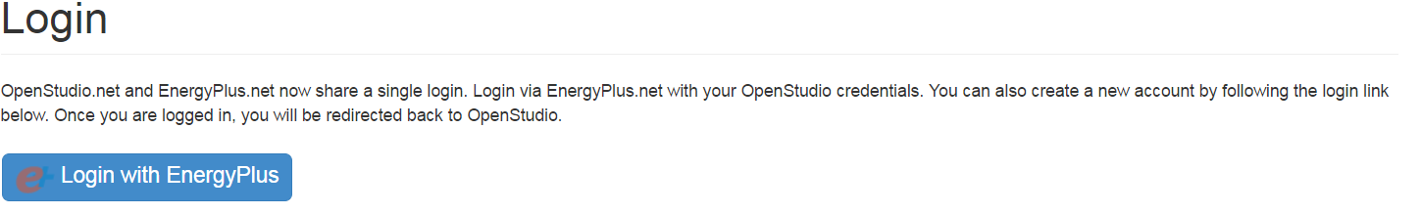
2. Once logged in, go to the OpenStudio download page. <https://www.openstudio.net/downloads>



1. Click on the link for Windows(x64) or Mac.­
   1. When available, OpenStudio 2.4.0 will also work for this exercise.
2. Run the installer, and make sure all OpenStudio components are selected as shown below.

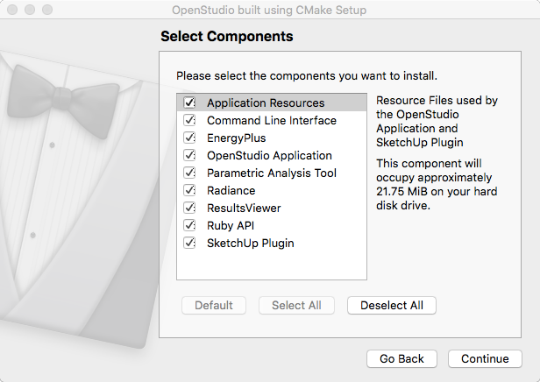

1. The OpenStudio® icon should now show up on the start menu on Windows or in your applications folder on Mac.